**Workflow Schedulers and Orchestration Tools**

**Executive Summary**

The landscape of workflow scheduling and orchestration tools has evolved significantly, with organizations demanding scalable, resilient, and feature-rich platforms to manage complex data pipelines, MLOps, and enterprise workloads. This report evaluates leading scheduling and orchestration solutions, including Control-M, Apache Airflow, Dolphin Scheduler, Kubeflow, Automic Automation UC4, Dagster, Luigi, and Redwood Workload Automation. The analysis is based on key criteria such as installation, CI/CD integration, scalability, workflow management paradigms, security, and monitoring capabilities.

**Market Trends**

* **Shift Towards Cloud-Native Solutions**: Kubernetes-native solutions like Kubeflow and Airflow on Kubernetes are gaining traction.
* **Low-Code and No-Code Adoption**: Enterprises seek UI-driven, low-code platforms to reduce dependency on development teams.
* **AI and MLOps Integration**: Kubeflow, Dagster, and Airflow are leading in ML pipeline automation.
* **Enhanced Observability & Resilience**: Self-healing, parallel execution, and monitoring are crucial for large-scale deployments.

**Evaluation Criteria**

The comparison is based on the following features:

1. **Installation**: Deployment ease, on-premise vs. cloud-native options.
2. **CI/CD & Git Integration**: Support for automation and DevOps best practices.
3. **Scalability & Resilience**: Handling high workloads, auto-scaling, self-healing.
4. **Workflow Management**: Programming paradigm (low-code, dynamic DAGs, declarative, UI-based flow).
5. **Authentication & Security**: LDAP authentication, RBAC, API security.
6. **Integration**: Support for databases, NoSQL, application workflows (ETL, streaming, batch jobs).
7. **Monitoring & Logging**: Visibility into workflow execution, failure handling, automated resumption.

**Magic Quadrant Analysis**

**Leaders**

* **Control-M**: Best-in-class enterprise workload automation, extensive integrations, and strong monitoring.
* **Apache Airflow**: Open-source leader for data engineering and workflow orchestration, widely adopted.
* **Kubeflow**: Dominant in MLOps, providing robust model training and deployment capabilities.

**Challengers**

* **Automic Automation UC4**: Enterprise-grade automation but requires specialized expertise.
* **Redwood Workload Automation**: Strong workload automation with high enterprise adoption.

**Visionaries**

* **Dagster**: Emerging data orchestration tool with a strong software-defined data asset approach.
* **Dolphin Scheduler**: Focused on ETL and batch processing, gaining adoption in Asia-Pacific.

**Niche Players**

* **Luigi**: Simple, Python-based pipeline orchestration for small-scale ETL workloads.

**Detailed Comparison**

|  |  |  |  |  |  |  |  |  |
| --- | --- | --- | --- | --- | --- | --- | --- | --- |
| **Feature** | **Control-M** | **Apache Airflow** | **Dolphin Scheduler** | **Kubeflow** | **Automic UC4** | **Dagster** | **Luigi** | **Redwood** |
| **Installation** | On-prem & Cloud | Python-based | Java-based | Kubernetes-native | On-prem & Cloud | Python-based | Python-based | Cloud-based |
| **CI/CD** | Yes | Yes | Limited | Strong | Yes | Strong | Limited | Strong |
| **Git Integration** | Yes | Yes | Yes | Yes | Yes | Yes | Yes | Yes |
| **Scalability** | High | Moderate-High | Moderate | High | High | Moderate-High | Moderate | High |
| **Programming Heavy** | No | Yes | No | Yes | No | Yes | Yes | No |
| **Low Code** | Yes | No | Yes | No | Yes | No | No | Yes |
| **Dynamic DAG** | No | Yes | No | Yes | No | Yes | No | No |
| **Declarative** | No | No | No | Yes | No | Yes | No | Yes |
| **UI-Based Flow** | Yes | No | Yes | No | Yes | No | No | Yes |
| **Primary Use Cases** | Enterprise Automation | Data Engineering | ETL & Batch Jobs | ML & MLOps | Enterprise Automation | Data Orchestration | Data Pipelines | Enterprise Workload |
| **MLOps Support** | Limited | Moderate | Limited | Strong | Limited | Moderate | Limited | Limited |
| **DataOps Support** | Strong | Strong | Moderate | Moderate | Strong | Strong | Moderate | Strong |
| **LDAP Authentication** | Yes | Yes | Yes | Yes | Yes | Yes | No | Yes |
| **Self-Healing** | Yes | Yes | Yes | Yes | Yes | Yes | No | Yes |
| **Dependency Management** | Yes | Yes | Yes | Yes | Yes | Yes | Yes | Yes |
| **Parameterization** | Yes | Yes | Yes | Yes | Yes | Yes | Yes | Yes |
| **Backfill** | Yes | Yes | Yes | Yes | Yes | Yes | Yes | Yes |
| **Data Passing** | Yes | Yes | No | Yes | No | Yes | No | Yes |
| **Parallel Execution** | Yes | Yes | Yes | Yes | Yes | Yes | Yes | Yes |
| **Automatic Resumption** | Yes | Yes | No | Yes | Yes | Yes | No | Yes |
| **State Management** | Yes | Yes | Yes | Yes | Yes | Yes | Yes | Yes |
| **API Availability** | Yes | Yes | Yes | Yes | Yes | Yes | Yes | Yes |
| **Monitoring & Logging** | Yes | Yes | Yes | Yes | Yes | Yes | Yes | Yes |

**Recommendations**

* **For Large Enterprises**: Control-M and Automic UC4 are best for reliability, security, and scalability.
* **For Data Engineering Teams**: Apache Airflow and Dagster offer flexible, Python-based orchestration.
* **For MLOps and AI Workflows**: Kubeflow is the go-to solution for model training and pipeline automation.
* **For Small & Mid-Sized Teams**: Luigi and Dolphin Scheduler offer lightweight, open-source orchestration.
* **For Cloud-First Strategies**: Redwood Workload Automation and Kubeflow provide strong cloud-native capabilities.

**Conclusion**

Organizations should select an orchestration tool based on workload complexity, scalability needs, and integration requirements. While enterprise solutions like Control-M dominate large-scale automation, open-source frameworks like Airflow and Kubeflow provide cost-effective, scalable solutions for data engineering and MLOps.

**Open Source Workflow Orchestration Systems**

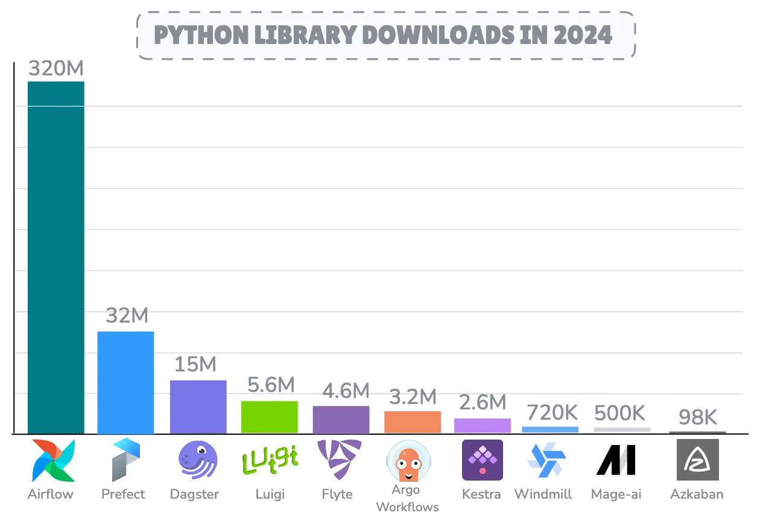

After a decade Apache Airflow continues to be the most deployed and adopted workflow orchestration engine with a staggering **320M downloads** in 2024 alone, while facing competition from rising competitors such as **Dagster**, **Prefect** and **Kestra**.

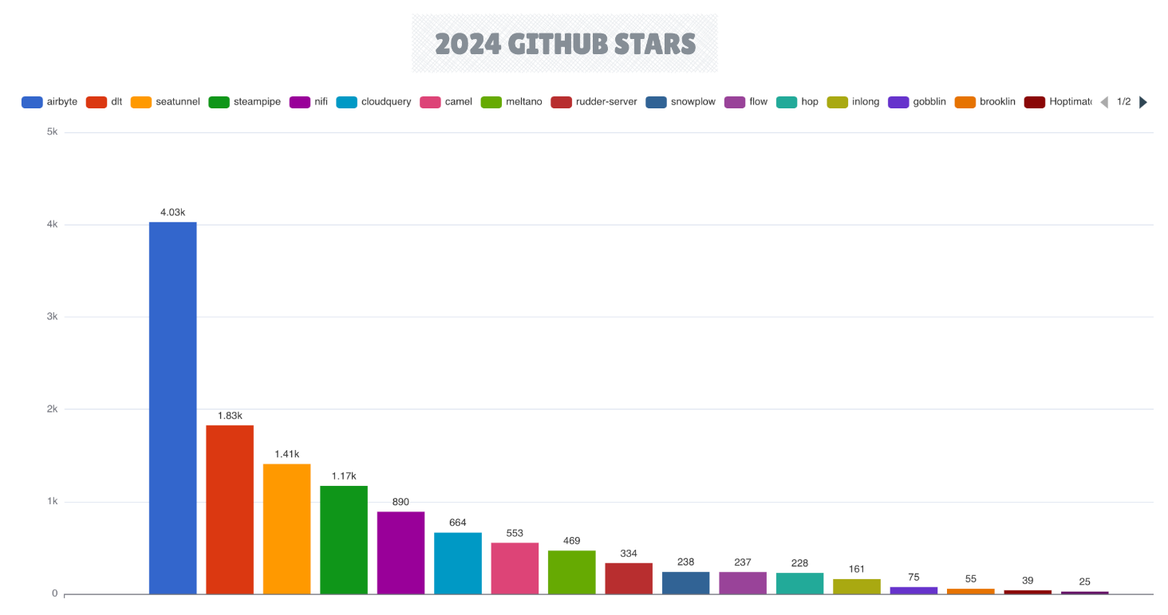

In the data integration space, **Airbyte** maintained its leadership position, achieving an impressive milestone by closing 13K pull requests in preparation for version 1.x. The **dlt** framework demonstrated significant maturation with its 1.0 release, while **Apache** **SeaTunnel** gained traction as a compelling alternative.

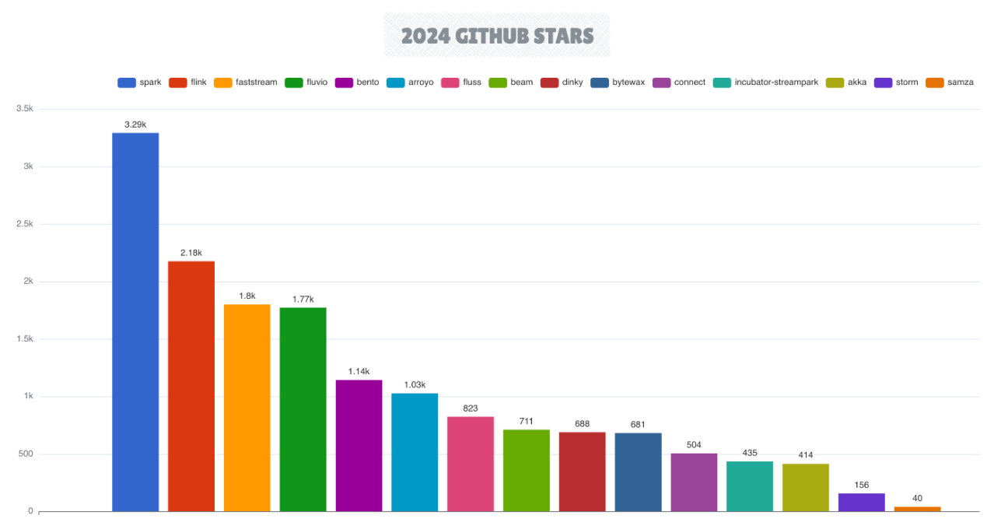

The stream processing ecosystem continued to expand in 2024, with **Apache Flink** further solidifying its position as the premier streaming engine, while **Apache Spark** retains it’s strong position.

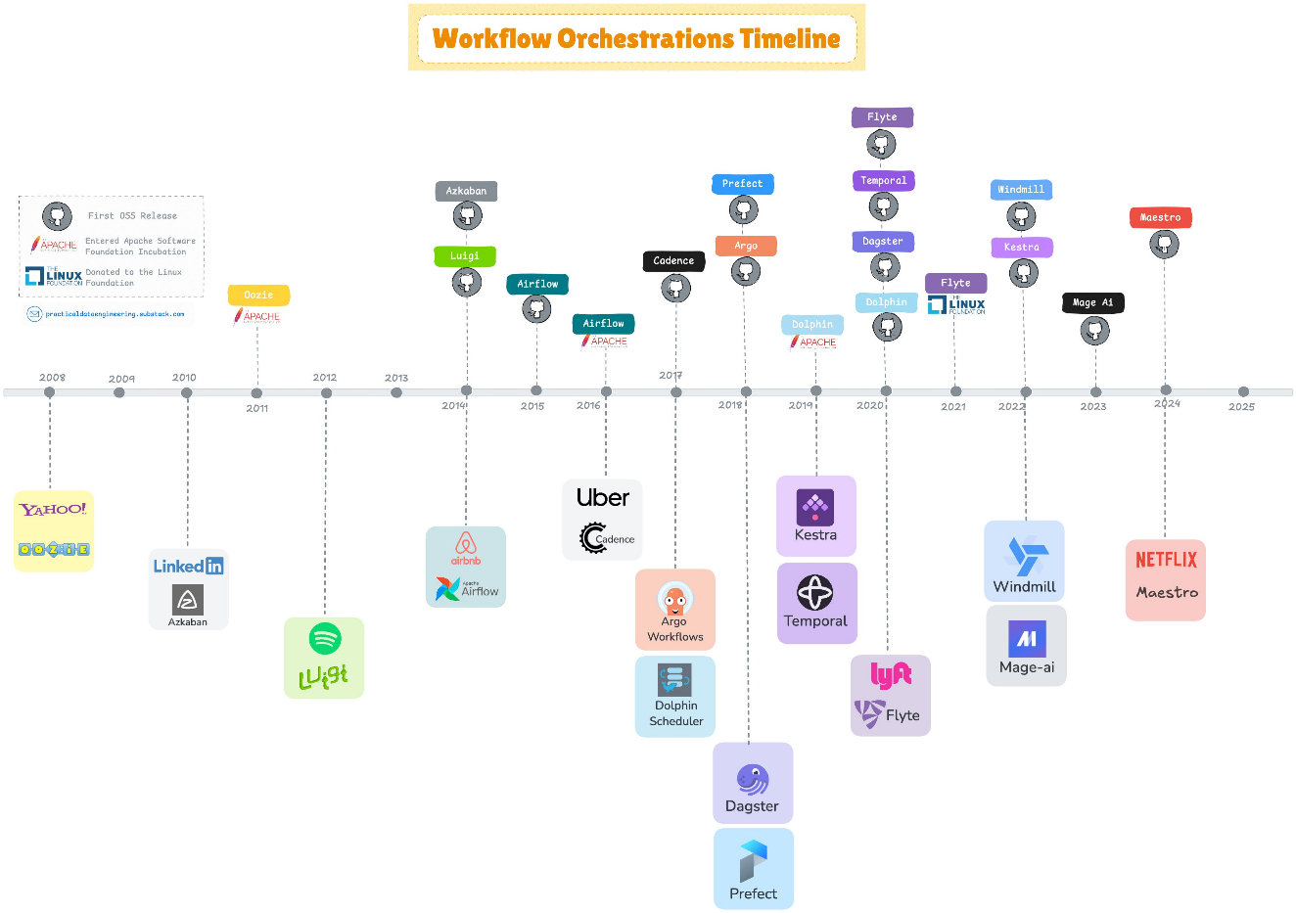

metin, ekran görüntüsü, renklilik içeren bir resim

Yapay zeka tarafından oluşturulan içerik yanlış olabilir.

**Conclusion & Recommendations**

After a decade, **Apache Airflow** remains the most mature and widely adopted orchestration tool in the data engineering ecosystem. Its position as the market leader is reinforced by major cloud vendors - Google **Cloud Composer** and Amazon **MWAA** have both standardised on Airflow for their managed workflow services.

While Airflow faces criticism for its steep learning curve, operational overhead, and not-so friendly UX with outdated UI (though a complete revamp is planned for the upcoming version 3.0), its primary technical limitation is its focus on batch-oriented workflows, with less native support for modern dynamic workflow patterns.

For **large-scale deployments** managing large number of heterogeneous workflows that require a general-purpose engine with extensive operations support and a large ecosystem, Apache Airflow remains the top choice. At the Airflow Summit 2024, major companies showcased Airflow's massive scalability, with [**Uber**](https://www.astronomer.io/blog/airflow-in-action-uber/) orchestrating 450K pipeline runs daily across 1000 teams, **Stripe** managing 150K tasks, and **LinkedIn** operating over 10K parallel DAGs.

For **startups**, and **small to mid-sized businesses** consider newer orchestration tools that offer streamlined setup and development experience through features like in-browser development environments, declarative workflow authoring, and low-code capabilities.

For **dynamic** and **data-centric** workflow orchestration, products like **Prefect** and **Dagster** excel at data-aware orchestration compared to traditional task-based schedulers.

**Temporal** introduced sophisticated resource management with its worker ***auto-tuning*** feature, which automatically adjusts worker slots based on real-time CPU and memory usage.

**Kestra** has introduced *task runners* that can dynamically offload resource-intensive tasks to on-demand compute services like Azure Batch, Google Batch, and Google Cloud Run.

**Dagster Pipes** became stable in version 1.8 released in 2024, with enhanced integrations for Lambda, Kubernetes, and Databricks looking ahead.

**DolphinScheduler** plans to integrate **KEDA** (Kubernetes Event-Driven Autoscaling), which will enable automatic worker scaling based on workload demands, further enhancing its Kubernetes-native capabilities.

**Prefect** and **Flyte** expanded their back-end execution capabilities in 2024 by enhancing support for distributed computing frameworks, integrating with scalable Python execution frameworks such as **Ray** and **Dask**, enabling more efficient parallel processing and distributed task execution.